RESTORING WATER QUALITY IN THE POLLUTED TURAG-TONGI-BALU RIVER SYSTEM, DHAKA: MODELLING NUTRIENT AND PATHOGEN INTERVENTION STRATEGIES

By

Paul Whitehead¹, Gianbattista Bussi¹, Mohammed Abed Hossain², Michaela Dolk¹, Partho Das², Sean Comber⁴, Rebecca Peters¹, Katrina J. Charles¹, Rob Hope¹ and Md. Sarwar Hossain³

¹ School of Geography and the Environment, University of Oxford, Oxford, OX1 3QY, UK

² Institute of Water and Flood Management (IWFM), Bangladesh University of Engineering and Technology (BUET) Dhaka 1000, Bangladesh

³ Institute of Geography, University of Bern, CH-3012 Bern, Switzerland
⁴ Department of Environmental Sciences, Plymouth University, Drake Circus, Plymouth, PL4 8AA, UK
Corresponding Author Email: paul.whitehead@ouce.ox.ac.uk; Tel: +44 7972 805 094
ABSTRACT
River water quality in rapidly urbanising Asian cities threatens to damage the resource base on which human health, economic growth and poverty reduction all depend. Dhaka reflects the challenges and opportunities for balancing these dynamic and complex trade-offs if water security goals can be achieved through effective policy interventions. There is a serious problem of water pollution in central Dhaka, in the Turag-Tongi-Balu River System in Bangladesh with the river system being one of the most polluted in the world at the moment. A baseline survey of water chemistry and pathogens has been undertaken and shows Dissolved Oxygen close to zero in the dry season, high organic loading together with extreme levels of ammonia and pathogens in the water. Models have been applied to assess hydrochemical processes in the river and evaluate alternative strategies for policy and the management of the pollution issues. In particular models of flow, nitrate, ammonia and indicator pathogens (Total Coliforms) are applied to simulate water quality in the river system. Various scenarios are explored to clean up the river system, including flow augmentation and improved effluent treatment. The model results indicate that improved effluent treatment is likely to have a more significant impact on reducing Ammonia-N and total coliforms than flow augmentation, but a combined strategy would greatly reduce the pollution problems in the Turag-Tongi-Balu River System.

KEY WORDS: Pollution Control, Bangladesh, Turag River, Balu River, Pathogens, Nutrients, Modelling Water Quality, Water Security, Poverty

INTRODUCTION
Environmental pollution in large rapidly developing delta cities is a major problem responsible for over 12.6 million deaths annually according to the World Health Organisation and UNICEF (Prüss-Üstün and Corvalán, 2006). The presence of high population numbers, unsanitary conditions, poorly regulated industrial discharges and untreated domestic effluents has ensured that many urbanised delta rivers are highly polluted. They also pose a significant health threat to people using the rivers, groundwaters and associated water supply systems (Pimentel et al., 2007, Vörösmarty et al., 2010, Kjellstrom et al., 2006. Similar to urban rivers systems in other rapidly industrializing developing countries, the rivers of Dhaka City, Bangladesh, are heavily impacted by the scale and intensity of economic growth. While Greater Dhaka is a major engine of growth for Bangladesh, representing 40% of GDP production, high levels of pollution, over-abstraction of ground water, and inefficient use means that the Turag -Tongi - Balu river system in central Dhaka (Figures 1 and 2) receives a huge load of domestic and industrial effluent. New industrial developments and townships enhance these pollution loads with devastating impacts on river water quality. In this paper we assess the impact of nutrient and pathogen pollution in the Turag-Tongi-Balu River system and consider the mass balance of chemical constituents in the river system.
We have utilised a dynamic process based flow and water quality model INCA (Integrated Catchment Model, Whitehead et al, 1998 a,b, 2016, Wade et al 2002) to simulate the behaviour of the catchment and river system. Water quality modelling is a useful technique to improve our understanding of the spatio-temporal dynamics of nutrients and pathogens in a river system, and can be used to explore the potential effects of different management and hydrological change scenarios on river water dynamics. Two management strategies have been considered in this study, namely, the introduction of effluent clean up technologies for key discharges along the river and the alteration of water flows in the upper Turag so as to increase the flows of water in low flow conditions. This study presents the first integrated flow and water quality model of pollution risks in urban Dhaka and aims to guide and support government efforts to systematically track and regulate significant pollution risks to people, the river and economic growth. The designation of rivers in Greater Dhaka as Ecologically Critical Areas (ECAs) in 2009 by the Ministry of Environment and Forestry creates a foundation for future restoration activities.
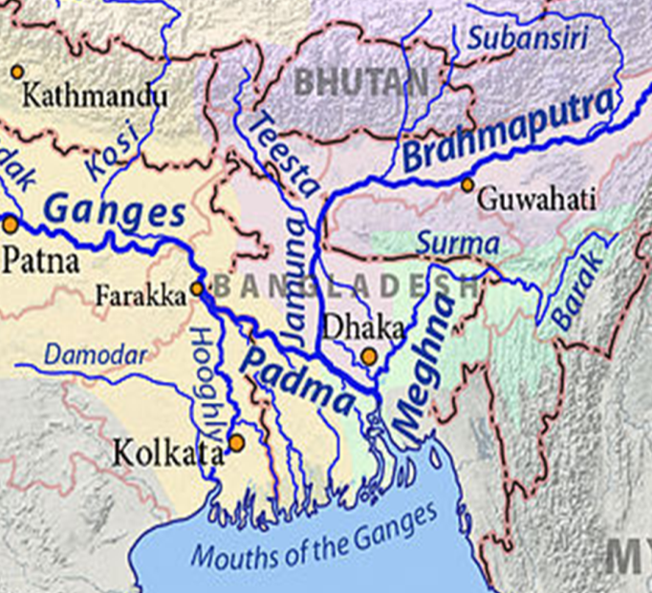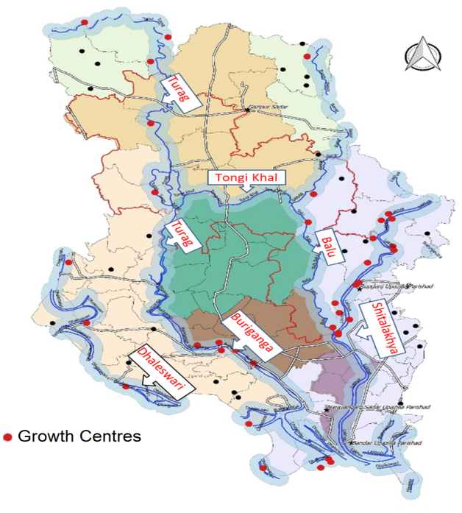

Figure 1 Maps showing Ganga, Brahmaputra and Meghna feeding into the Bangladesh Delta and Dhaka (left) and details of the Turag- Tongi - Balu River System around Dhaka (right)

THE TURAG-TONGI-BALU CATCHMENT SYSTEM
The city of Dhaka, capital of Bangladesh, is located in the centre of the country, north of the confluence of the River Padma (combined Ganga and Brahmaputra) and Meghna. The Turag-Tongi-Balu Rivers are part of a complex peripheral system of rivers surrounding Dhaka, as shown in Figure 1 (Alam and Khan, 2014). Seasonal flow variability in this river system is related to the region’s climate, characterised by a hot pre-monsoon summer season (March to May), a rainy monsoon season (June to September), a post-monsoon autumn season (October to November), and a dry winter season (December to February) (WARPO, 2004, Shahid, 2010). The Turag River is fed by runoff coming from a predominantly agricultural area located upstream, as well as from other rivers such as the Bangshi River and the Brahmaputra River, and flows into the Buriganga River, in the South of Dhaka. Land use is changing rapidly in the peripheries of Dhaka, with multi-spectral satellite data showing rapid conversion from agricultural cultivated land to urban land uses along Tongi Khal over the past few decades (Dewan and Yamaguchi, 2009, Dewan et al., 2012). Improved sanitation coverage in this new urban area is currently low, with the drainage system used as a combined sewerage system in a large portion of the area, presenting a source of microbial contamination of the river system. Precise estimates of effluent loads from various sources along the river are unavailable, in part due to the rapid pace of change which means that data is quickly outdated. Dhaka is one of the most densely populated cities in the world, home to approximately sixteen million people, of which less than 25% are served by sewage treatment facilities (Islam et al., 2015). In the last twenty years, a convergence of unregulated industrial expansion, rural-to-city migration, overloaded infrastructure, unclear institutional responsibility for water quality management and ineffective enforcement of environmental regulations have all taken their toll on surface water quality. Though there are plans for a number of sewage treatment plants by 2025, there is no sewage treatment plant serving the northern part of Dhaka at the moment which is of concern. Whilst many industries claim to have effluent treatment system, there is no clear evidence that these operate in any systematic manner. Almost all the waste from humans, industry, and millions of farm animals, along with tonnes of pesticides and fertilizers, make their way into Dhaka’s surface water untreated, and a percentage of these wastes infiltrate to the groundwater. As a result, pollutant levels in the groundwater are increasing, as are those in many sections of the rivers and canals in the city and surrounding areas. Pollution increases to alarming levels in the dry season (MoEF, 2010). Sayed et al. 2015 found significant changes in the major land use patterns of Dhaka city using remote sensing and reported that industrial expansion in Dhaka city has increased approximately 20% between 2004 and 2010 and brickfields also increased 5% within the same period. Brickfields are also one of the major sources of water and air pollution in Dhaka city. The sewerage and sanitation network of Dhaka city covers only 25% of the total urban area. In the absence of an appropriate waste management system, over 50% of municipal waste is disposed into the water bodies of Dhaka city. Therefore, it is highly challenging to identify the location of the pollution sources around the Turag-Tongi-Balu River System (Sabit and Ali 2014, MoEF, 2010).

WATER QUALITY IN THE RIVER SYSTEM
Given the extensive sources of pollution in the Turag-Tongi-Balu system, it is not surprising that the observed concentration data highlights the poor water quality. A comprehensive sampling programme has been conducted by BUET (Bangladesh University of Technology) and Figure 2 shows the spread of sampling sites along the river system. All the samples and measurements were taken from the middle of river at the designated sample points decided from literature, satellite imagery and a number of reconnaissance visits to the river system. Some of the parameters were analysed in-situ with HACH HQ40d multi-parameter meter which can measure pH, dissolved oxygen (DO), oxidation-reduction potential (ORP), electrical conductivity (EC) and Total Dissolved Solids (TDS). Measurements were made and samples collected from a depth of 2ft from the surface to avoid wave turbulence and debris. Samples of 500 ml were collected using an automatic wastewater sampler (Global Water WS 755) to ensure steady collection of samples and stored in pre-acid washed Teflon coated reagent grade plastic bottles. Bottles were capped following standard EPA guidelines to remove air and placed in ice boxes to limit biological activities. Filtered samples were used for measuring chemical oxygen demand (COD), nitrate, ammonia and phosphate using spectrophotometric methods. For this a HACH DR-6000 spectrophotometer was used following HACH pre-calibrated standard methods. Microbial analysis included measurements of total coliforms (TC) and E.coli no./100ml undertaken using standard methods. For each sample, 100 ml were filtered using 0.45 µm cellulose nitrate filters, which were attached to adsorbent pads soaked in m-ColiBlue24 broth in a pre-sanitized petri dish, and the assembly was incubated at 35°C for 24 hours. The colonies on the filters were counted using a digital colony counter after the incubation period. The dilution ranged from 1000 to 10000 for samples where the dilution was decided from samples from reconnaissance visits and literature. Figure 3 shows plots of the profiles of water quality along the main river system with data means at different reaches for Nitrate-N, COD, DO, Ammonia-N and TC, as an indicator of pathogens. The Nitrate-N shows quite high concentrations higher up in the catchment reflecting agricultural development in the upper reaches of the Turag, but the concentration falls as the Nitrate-N moves down the river system, suggesting both dilution and denitrification. The COD levels are very high indicating significant effluent and industrial discharges. There is a major difference between the wet and dry periods, with much higher COD in the dry season. This is due to the low flows and hence reduced dilution of effluents and discharges. The high COD, and by association, high BOD, also causes extremely low DO levels, as shown in Figure 3. DO is close to zero in certain reaches in the low flow period which creates anoxic conditions, leading to many pollution problems such as the release of noxious gases such as hydrogen sulphide, and dissolution of metals from the sediments into the water column. These can cause serious health problems. The Ammonia-N and TC concentrations also become very high with Ammonia-N reaching 16 mg/l and TC rising to 800,000 no./100ml. The Ammonia-N also creates low oxygen conditions as Ammonia-N nitrifies to nitrate and utilises oxygen for the river water. Plus there will be a large release of nitrous oxide gas (a greenhouse gas) from denitrification processes. Thus the Turag-Tongi-Balu system is highly polluted and there is a need to make a major effort to clean up the river system and restore it to reasonable health.
Figure 2 Location of sampling sites along the river system.
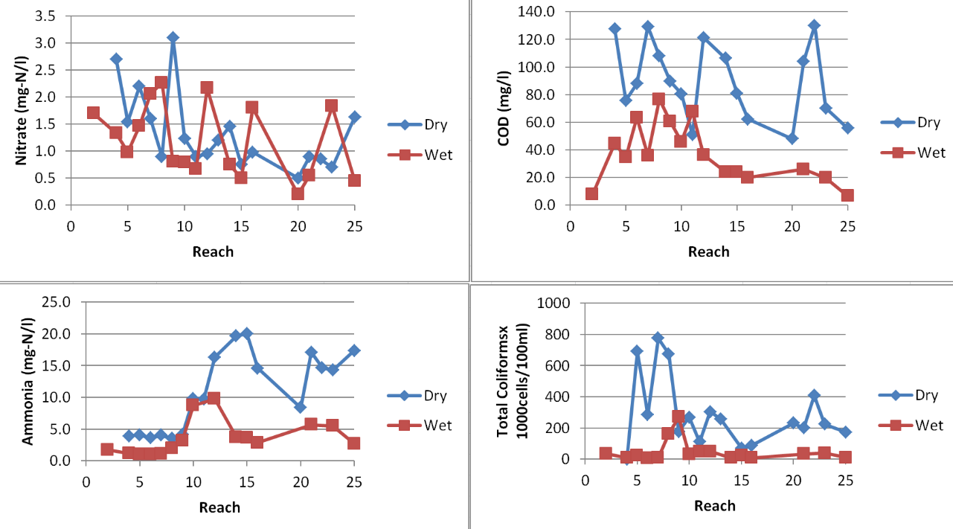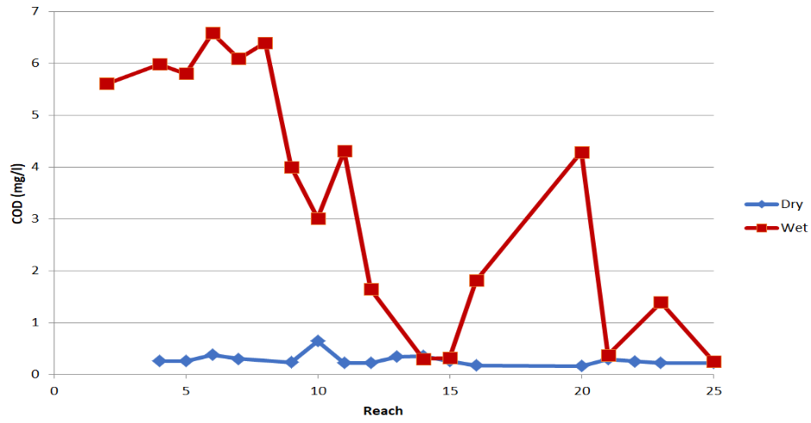
Figure 3 Mean Water Quality Concentrations along the Turag-Tongi-Balu System
THE INCA (INTEGRATED CATCHMENT) FLOW AND QUALITY MODEL
There are relatively few models of whole catchments that incorporate the soil and groundwater components as well as river channel dynamics, despite the fact that many problems are caused by nonpoint source or diffuse pollution. Where such models do exist they are often driven by overly complex hydrological models. In an attempt to develop a process-based water quality model with hydrology and water quality modeled at the same level of complexity, a model called the Integrated Catchments Model (INCA) has been developed. The INCA model simulates the main processes related with rainfall-runoff transformation and the cycle and fate of several compounds, such as nitrate, Ammonia-N, pathogens, metals and phosphorus (Whitehead et al.,1998, Wade et al., 2002, Wade et al, 2002, Whitehead et al, 2015, Jin et al 2015). In terms of nitrogen, the modeled processes include mineralization, nitrification, denitrification, immobilization, plant uptake, and nitrogen fixation, as indicated in Figure 4. Both surface soil zones and groundwater zones are simulated together with leaching of water into the river system (Figure 4). Sources of nitrogen can be from atmospheric deposition (i.e. from local or remote sources such as power stations, industry, or vehicles), from point sources such as sewage discharges, or from distributed sources such as agricultural fertilizers or natural organic sources of nitrogen. The INCA-Pathogens model is also a process-based model and simulates pathogen stores in soils, groundwater, sediments, and river water (Whitehead et al., 2016). The pathogens model accounts for both diffuse pathogen sources, such as those from agricultural areas, as well as point sources, including sewage treatment works and industrial sources (see Figure 5). The model simulates a range of processes governing microbial transport, growth and die-off, and parameters may be varied at a sub-catchment scale to enable a spatially variable representation of key processes. A full description of the pathogens model and applications in England, Wales and Finland are given by Whitehead et al. (2016), Bussi et al (2017), Rankinen et al (2016).
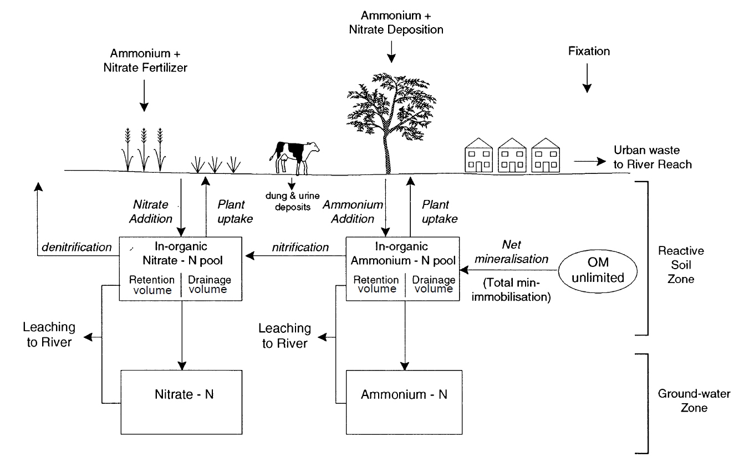
Figure 4 The key process in the land component of nitrogen cycle
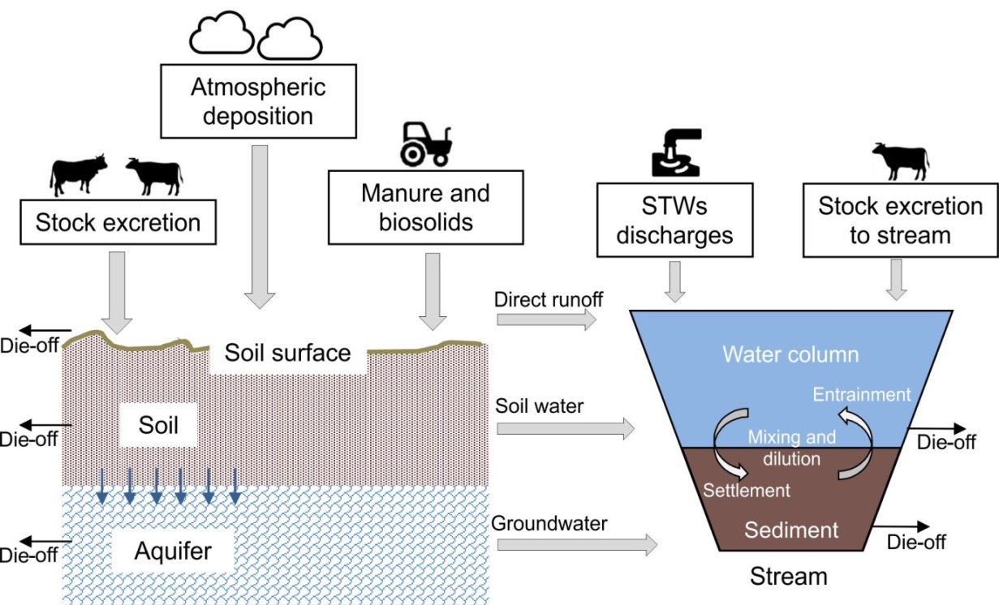
Figure 5 Schematic representing the sources, transport mechanisms and stores of pathogens in the environment
APPLICATION OF INCA TO TURAG-TONGI-BALU SYSTEM
INCA requires daily time series of precipitation, hydrologically effective rainfall (HER), temperature and soil moisture deficit (SMD), as can be seen in Figure 6. Observational data are available from in situ weather stations and also from satellite measurements and these have been integrated into observational datasets which cover the region as part of the Aphrodite online data system Yatagai et al, 2012). More information can be found in Caesar et al. (2015) and Whitehead et al. (2015). Observations of flows, pathogen indicators, nitrate-N and Ammonia-N concentrations are required in order to adjust the INCA model parameters in order to calibrate and validate the model. River flows and water chemistry data have been used to compare observed and simulated values for calibration and validation. Flow data are available at the Mirpur Bridge on the Turag River for the high flow season (June-October).
Spatially distributed information is required in order to estimate several of the INCA model parameters. Some of them are detailed as follows.
- Digital elevation model. The elevation information was obtained from the Shuttle Radar Topography Mission (SRTM). SRTM is an international research effort to obtain digital elevation models on a near-global scale from 56° S to 60° N
- Land use/land cover. The land use information was obtained from the GlobCover Portal. GlobCover is an ESA (European Space Agency) initiative whose aim is to develop a service capable of delivering global composites and land cover maps using as input observations from the 300m MERIS sensor on board the ENVISAT satellite mission
- Atmospheric deposition. This information was obtained from the global map of atmospheric nitrogen deposition 1993 (Dentener, 2006), distributed by the Distributed Active Archive Center for Biogeochemical Dynamics of the Oak Ridge National Laboratory (DAAC ORNL). The average value is 29 kg ha⁻¹ yr⁻¹.

- Population map. This map may be useful to define the flow and nutrient concentrations of treated wastewater discharges, in case direct measurement is not available. This was obtained from the Gridded Population of the World (GPW) of the Socioeconomic Data and Applications Centre (SEDAC): http://sedac.ciesin.columbia.edu/data/collection/gpw-v3.

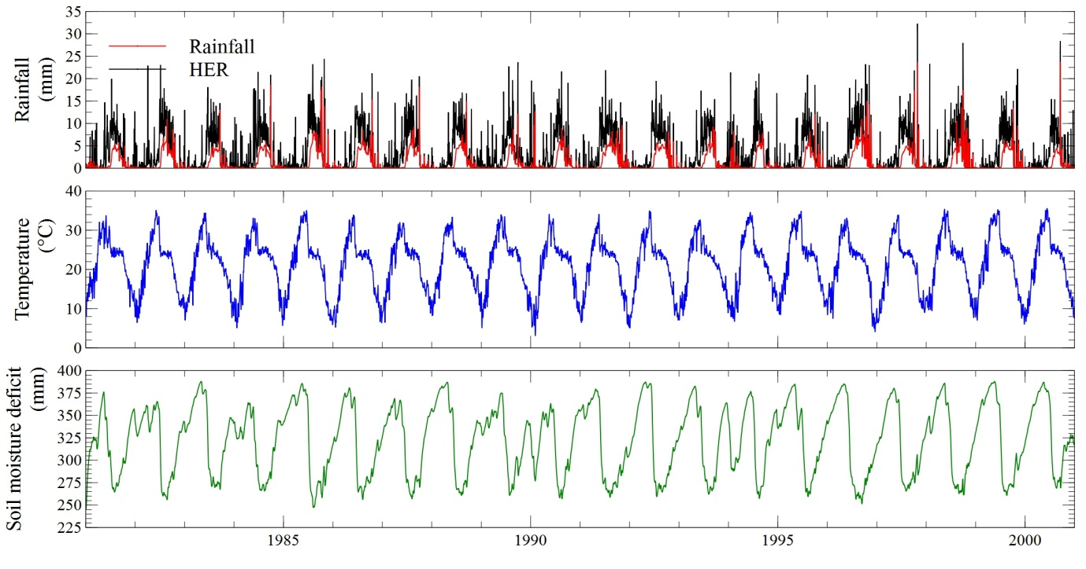
Figure 6 INCA model inputs of daily rainfall, hydrologically effective rainfall (HER), temperature and soil moisture deficit (SMD)

Model set-up- Sub-catchment and Reach Structure
The reach structure of the Turag-Tongi-Balu system is complex, with the Tongi Khal connecting the Turag and Balu Rivers, as shown in Figure 7. This figure also shows the upper reaches of the Turag and the linkage to the Brahmaputra, as well as the details of the lower reaches. The river system has been divided up into 24 reaches as indicated in Table 1, which gives the reach lengths and the sub catchment areas associated with each reach. In terms of hydrology the system is complicated by the overland flows from the Brahmaputra during flood conditions (Figure 7). These Brahmaputra overland flows feed into the upper Turag and need to be accounted for in any flow simulation so that the correct flows are simulated in the lower reaches. This also ensures the correct dilution factors are computed in the INCA model and are applied to effluent discharges and diffuse runoff pollution in all reaches. The extent of the connection between the Brahmaputra and the upstream Turag is difficult to estimate, as it is not measured. However, we have estimated the extra flows by comparing the observed flows in Reach 8 with the simulated natural catchment flows. The difference then gives an estimate of the Brahmaputra overland flows entering the upper Turag. This extra flow can then added back into the model as the additional flood flows into the upper Turag. As shown in Figure 8, we generate model simulated flows that match the limited wet season observation data. The simulated Nitrate-N and Ammonia-N (Figure 8) indicate low concentrations in monsoon periods when flows are high and the dilution is large, but higher concentrations in the low flow periods when little dilution occurs.
Due to a lack of data, effluent discharges for each reach were estimated by running the model in a “reverse-mode” and comparing the pattern of simulated and observed water quality along the river. In the case of the pathogens model, observations for total coliforms were sourced from the water quality surveys, which measured water quality at numerous locations along the Turag-Tongi-Balu River system (Figure 2). A similar method of running the model in a “reverse-mode” to estimate the contaminant discharges was used in a study of perfluoroalkyl substances by Sharma et al. (2016) in a similarly data-scarce context. Effluent discharges were estimated separately for the wet (May to October) and dry (November to April) seasons due to the substantially higher runoff (and hence higher effluent loads) during the wet season. The total coliform concentration of the effluents was calibrated by comparing the distribution of simulated values to observed data for Reach 9. Model process parameters such as the pathogen die-off rate, growth rate and light decay rate were based on values from the literature, as shown on Table 2 (Whitehead et al., 2016), and this was necessary because of the lack of any process rate data for the triver system. As shown in Figure 9 and Figure 10 the profile down the river system from the model compares well with the observed profiles of TC and Ammonia-N, although ammonia shows some spikes probably due to the sampling site being immediately downstream of an effluent discharge. The model fits to the data along the river gives R² of 0.79 for ammonia and 0.76 for pathogens, so this gives some confidence that the model is representing the water quality in the river system.
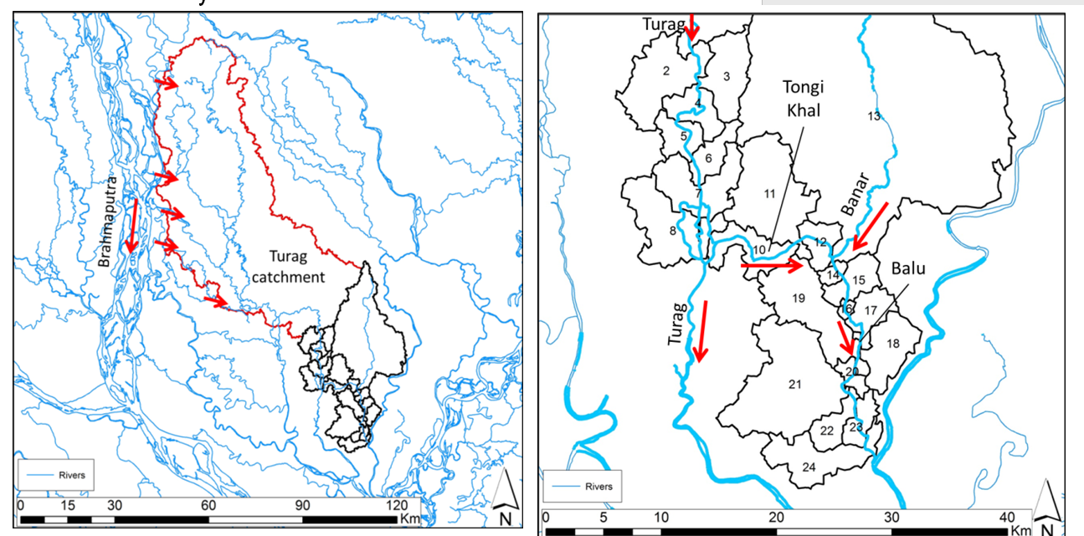
Figure 7 Reaches and sub-catchments of the Turag-Tongi-Balu River System around Dhaka. Left map shows the upper Turag and the flood flows from the Brahmaputra. The right map shows the reach boundaries in the middle and lower reaches of the Turag-Tongi-Balu System (red arrows indicate directions of flow in the wet season).
Table 1 Turag-Tongi-Balu River System reaches, sub-catchments and land use
Reach number | Reach length (m) | Catchment area (km²) | Urban (%) | Arable (%) | Wetland (%) | Natural-Mixed (%)
1 | 150000 | 3026.28 | 0.02 | 99.5 | 0.12 | 0.36
2 | 3140 | 35.79 | 38.31 | 59.28 | 0 | 2.41
3 | 550 | 23.72 | 0 | 98.53 | 0 | 1.47
4 | 4320 | 14.17 | 0 | 71.25 | 0 | 28.75
5 | 4030 | 11.48 | 0 | 85.71 | 0 | 14.29
6 | 2530 | 11.22 | 0 | 100 | 0 | 0
7 | 4880 | 28.19 | 4.6 | 85.58 | 0 | 9.82
8 | 1870 | 36.66 | 1.43 | 84.01 | 0 | 14.56
9 | 340 | 2455.98 | 70.48 | 26.87 | 0 | 2.65
10 | 10950 | 19.90 | 64.62 | 35.2 | 0 | 0.18
11 | 470 | 49.84 | 6.45 | 68.55 | 0 | 25
12 | 4020 | 10.65 | 0.38 | 92.97 | 0 | 6.65
13 | 600 | 507.07 | 0 | 66.67 | 0 | 33.33
14 | 1370 | 3.50 | 0 | 88.59 | 0 | 11.41
15 | 2310 | 12.83 | 0 | 50 | 0 | 50
16 | 1450 | 1.87 | 0 | 77.24 | 0 | 22.76
17 | 3330 | 12.25 | 0 | 68.75 | 0 | 31.25
18 | 830 | 21.53 | 59.78 | 17.14 | 0 | 23.08
19 | 1540 | 39.36 | 0 | 75 | 0 | 25
20 | 1780 | 4.91 | 94.41 | 2.11 | 0 | 3.48
21 | 550 | 70.28 | 80.95 | 17.46 | 0 | 1.59
22 | 2220 | 10.70 | 62.63 | 29.29 | 0 | 8.08
23 | 2865 | 8.69 | 100 | 0 | 0 | 0
24 | 1680 | 27.45 | 0.83 | 95.17 | 0.99 | 3.01

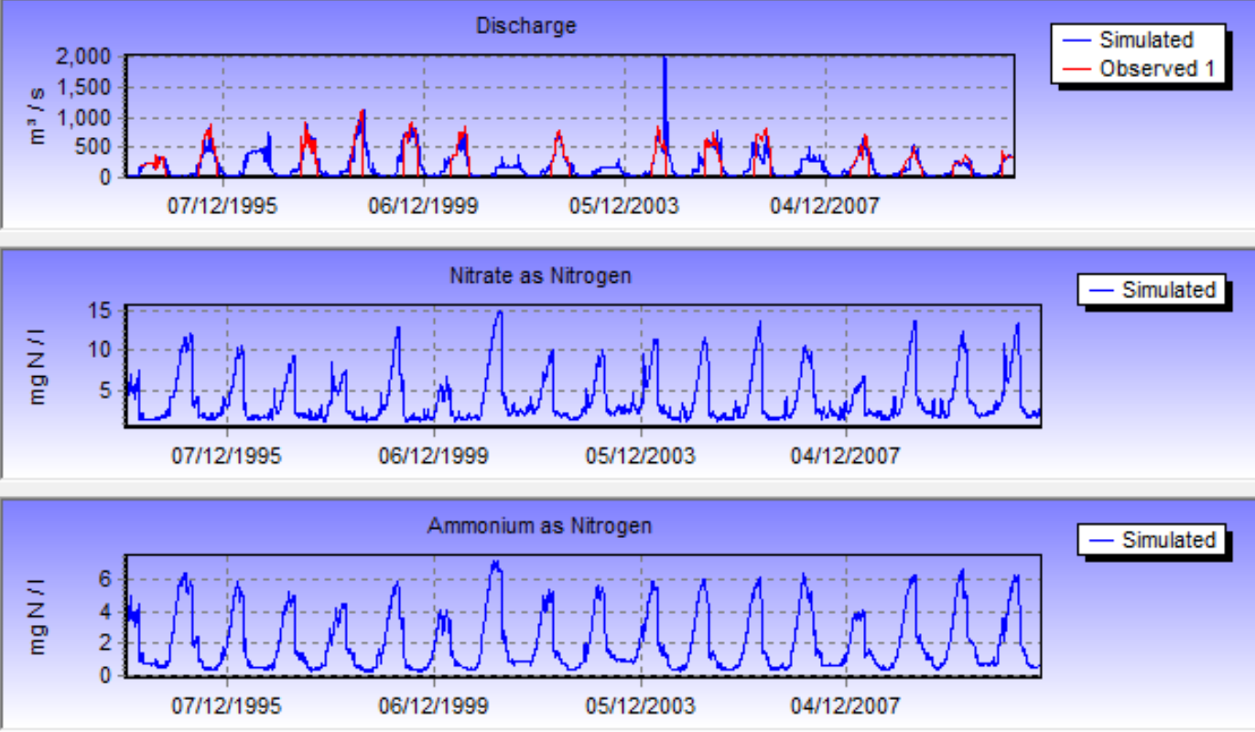

Figure 8 Simulated and Observed Flow in Reach 8 of the Turag Model and simulated Nitrate (as N) and Ammonia (as N) Concentrations

Table 2 Generic parameters for Turag-Tongi-Balu River system INCA-Pathogens model
Parameter | Value
Land phase
Soil water processes: Die-off rate | 0.6 day⁻¹
Soil water processes: Growth rate | 0 day⁻¹
Soil water processes: Light decay rate | 0.1 day⁻¹
Inputs: Manure: Manure addition rate: Arable | 1E6 no./ha/day
Inputs: Animals: Animal addition rate: Arable | 1.4E6 no./ha/day
Inputs: Animals: Animal addition rate: Urban | 6E6 no./ha/day
Inputs: Animals: Animal addition rate: Natural-Mixed | 1.4E6 no./ha/day
Direct runoff residence time | 1.2 days
Soil water residence time | 5.7 days
Water column
Light decay proportionality constant | 0.5
Decay rate | 0.6 day⁻¹
Growth rate | 0 day⁻¹
Sediment
Shear velocity threshold for resuspension | 0.005 m/s
Deposition rate | 0.5 day⁻¹
Resuspension rate | 0.1 day⁻¹
Growth rate | 0 day⁻¹
Decay rate | 0.5 day⁻¹
Physical attributes
Base flow index | 0.7

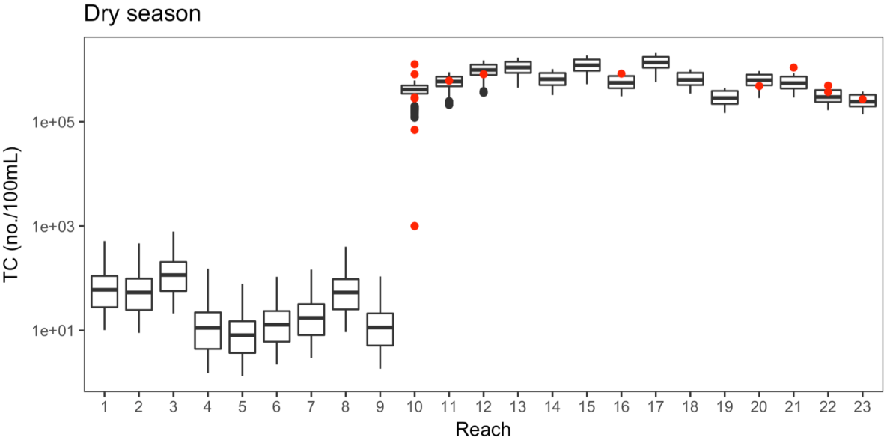
Figure 9 Comparison of modelled (boxplot) and observed (red dots) total coliform for the reaches of the Turag-Tongi-Balu River system. The first and third quartiles are represented by the lower and upper boxplot hinges, respectively. The median is represented by a line, and the upper and lower whiskers extend to the largest and smallest values, respectively, within 1.5 times the interquartile range of the upper and lower hinges.
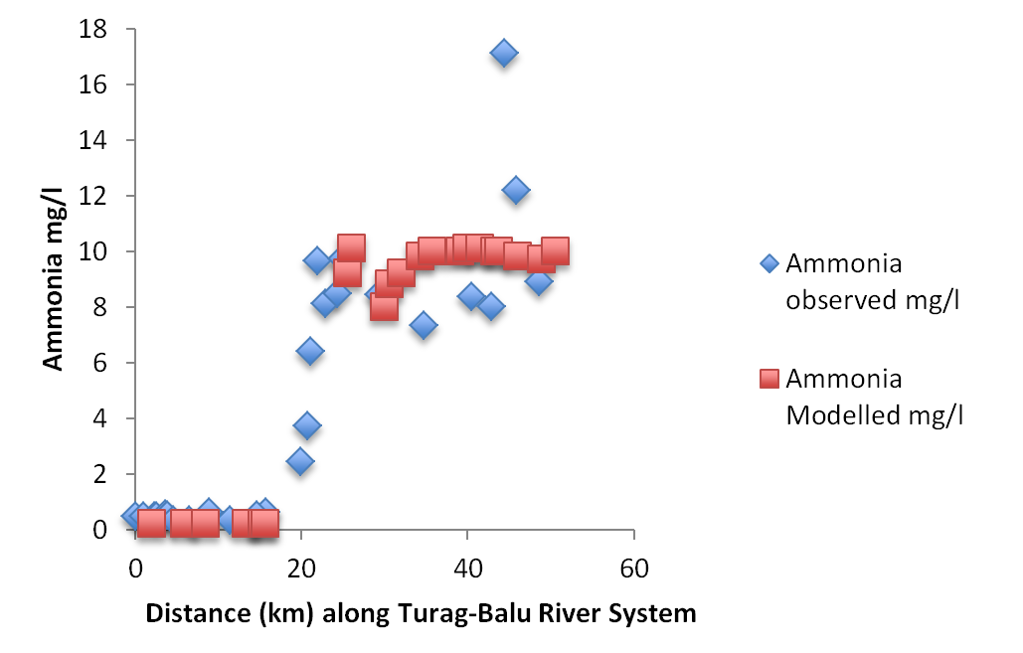
Figure 10 Mean Modelled and Observed Ammonia-N along the Turag-Tongi-Balu River System in the Dry period
RESTORATION MEASURES
Having established the INCA models for Total Coliforms and Ammonia-N, we can use the model setup to evaluate a series of management alternatives to address the serious pollution problems along the river system. Two management strategies have been considered in this study: the introduction of effluent clean up technologies for key discharges along the river, and the alteration of water flows in the upper Turag to increase the flows of water in low flow conditions. Figure 11 shows the effects of these strategies on the Ammonia-N concentrations along the river system, as well as what would happen if both were implemented together. With effluent treatment, assuming that ammonia is reduced from 19 mg/l in the effluent discharges to 5mg/l, then this would result in a significant reduction in ammonia in the river system, as shown in Figure 11. Flow augmentation would involve creating a canal or link between the Brahmaputra and the upper Turag. Allowing an augmentation flow of 20m³/sec during the dry period the dilution effects would be significantly enhanced, halving the Ammonia-N concentrations to approximately 6mg/l (Figure 11). The best solution is to combine these policies, and this would reduce the ammonia levels to low concentrations of 1 to 2 mg/l. These two strategies would also reduce the concentrations of other pollutants such as BOD and COD, as well as metals and organics. This would therefore transform the river from being one of the most polluted in the world to being a safe river of average to good water quality with dissolved oxygen concentrations of 5-7 mg/l or at 80% saturation. This combined strategy would also prevent the anoxic conditions in the sediments preventing the release of metals into the water column and contribute to a reduction in noxious gas formation.
In terms of pathogens a similar set of conclusions can be drawn. The calibrated value of effluent total coliforms was 1 x 10⁶ no./100ml. If waste were collected and treated in well-managed STWs, this discharge might be reduced and, as in the case of ammonia, the instream pathogen concentrations would be reduced. This would also be enhanced in the dry period with flow augmentation. As shown in Figure 12, the model results do indeed show that flow augmentation and improved effluent treatment will reduce total coliform counts in the Turag-Tongi-Balu River system. Over the range of scenarios considered, it appears that improved municipal effluent treatment has the potential to provide greater reductions in total coliform counts. However this assumes collection of all wastes, including from the large slum populations. This change in concentrations and flow is being further analysed for potential health impacts, considering the behaviours observed among riparian populations (Dolk, Charles and Whitehead, 2018, in preparation). Of course, strategies to improve water quality will be expensive and their application is likely to be influenced by wider economic and political concerns.

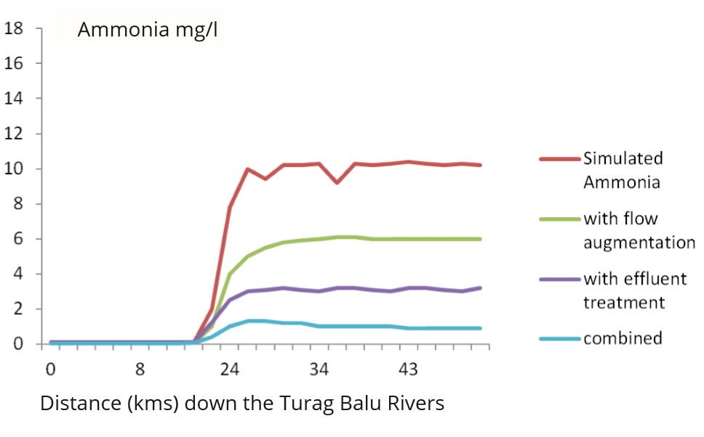
Figure 11 Simulated Ammonia-N on the Turag-Tongi-Balu System under scenarios of effluent treatment and flow augmentation
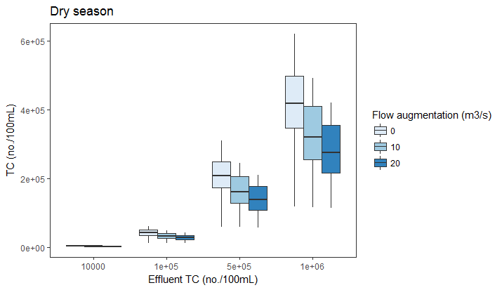
Figure 12 Modelled TC at reach 10 under 3 flow augmentation strategies (0 m³/s, 10 m³/s and 20 m³/s) and with sewage treatment imposed for effluent total coliforms of 1E+06 , 5E+05, 1E+05 and 1E+04 No./100ml, corresponding to a 0%, 50%, 90% and 99% reduction respectively

CONCLUSIONS
The INCA-N and Pathogens models are able to simulate spatial and temporal patterns in ammonia, nitrate and total coliform along the Turag-Tongi-Balu River system. The scenario analyses indicate that improved effluent treatment and flow augmentation are likely to have a great impact on reducing pollutant levels in the river system. This combined strategy to reduce pollution and enhance the low flows is recommended. This approach also aligns with government policy. However the costs of new Sewage Treatment Works (STWs) plus the cost of canals or diversions to enhance summer flows upstream will be high. The model can be used to evaluate alternative designs such as the number, efficiency and location of STWs, the flows required by the canal, and hence canal size in order to evaluate the most cost effective solution. Improving water quality is a key priority for the government and a stronger evidence base can help target the most beneficial investments for people, ecosystems and industry. Dissolved oxygen is a key indicator of ecosystems health and there is a strong need to significantly improve current DO levels to bring them back to internationally accepted ranges.
It should be noted that there are always limitations on studies of water quality and modelling in complex river systems. There is limited data available on the effluent discharges as many discharges are not monitored or measured, plus there are model uncertainties associated with parameterisation of the models. Again this is due to the lack of measurement but literature values of parameter and the extensive experience of applying INCA to over 50 catchments worldwide gives confidence that the model is representative of the river systems. Furthermore, the scenarios selected are just example evaluations of restoration strategies. Considerable additional work would be needed to evaluate the local details of an augmentation flow approach or the details treatment of discharged effluents.
This study has highlighted the role of mathematical modelling in low resource environments where data are both sparse and difficult to capture given the complexity and dynamic nature of the environmental, economic and political context. The rapid growth of Dhaka and the importance of new industries such as the garment industry which is generating over USD 25 billion per year is a key issue for Bangladesh. Such industries create work for mainly female workers lifting multiple more people out of poverty. However planned future growth to double such development by 2021 will depend on protecting the river to balance growth with environmental sustainability, human health and job creation.
ACKNOWLEDGEMENTS
This document is an output from the REACH programme funded by UK Aid from the UK Department for International Development (DFID) for the benefit of developing countries (Aries Code 201880). The research is part of the REACH ‘Water security for an urban river’ Observatory. This includes key stakeholders including the Government of Bangladesh’s Department of Environment (DoE), GED under Planning Commission, WARPO, BWDB, DPHE and Bangladesh Water MSP (especially GDWR work stream), Dhaka University. We also acknowledge the support extended to REACH from JICA funded SATREPS project at BUET in river sampling, data sharing and analytical measurements.
We also acknowledges the support of the DECCMA Project on ‘DEltas, vulnerability and Climate Change: Migration and Adaptation’ which is part of Collaborative Adaptation Research Initiative in Africa and Asia (CARIAA), with financial support from the UK Government’s Department for International Development (DfID) and the International Development Research Centre (IDRC), Canada.
The views expressed and information contained in this document are not necessarily those of or endorsed by DFID, which can accept no responsibility for such views or information or for any reliance placed on them.
REFERENCES
Dentener, F.J., 2006. Global maps of atmospheric nitrogen deposition 1860, 1993, and 2050, data set, Oak Ridge National Laboratory Distributed Active Archive Center, Oak Ridge, Tennesee, USA. doi:10.3334/ORNLDAAC/830
Dewan, A.M. and Yamaguchi, Y. (2009) Land Use and Land Cover Change in Greater Dhaka, Bangladesh: Using Remote Sensing to Promote Sustainable Urbanization. Applied Geography, 29, 390-401
Dewan, A.M., Yamaguchi, Y. and Rahman, M.Z. (2012) Dynamics of Land Use/Cover Changes and the Analysis of Landscape Fragmentation in Dhaka Metroploitan, Bangladesh. GeoJournal, 77, 315-330.https://doi.org/10.1007/s10708-010-9399-x
Dolk, M.,. K Charles P Whiltehead (in prep). QMRA: Health risk analysis of water from the Turag River System.
Islam, S., Ahmed, K., Al-Mamun, H., Masunaga, S., 2015. Assessment of trace metals in fish species of urban rivers in Bangladesh and health implications. Environ. Toxicol. Pharmacol. 39, 347–357. doi:10.1016/j.etap.2014.12.009
Kjellstrom, T., Lodh, M., McMichael, T., Ranmuthugala, G., Shrestha, R. and Kingsland, S., 2006. Air and water pollution: burden and strategies for control.
Lu, Q., Whitehead, P.G., Bussi, G., Futter, M.N., Nizzetto, L., 2017. Modelling metaldehyde in catchments: a River Thames case-study. Environ. Sci. Process. Impacts 19, 586–595. doi:10.1039/C6EM00527F
MoEF, 2010. Po l l u t i o n Abatement Stra t e g i e s for River s and Wetlands in and Around Dhaka City, Parliamentary Standing Committee on Ministry of Environment and Forests (MoEF), Government of the People's Republic of Bangladesh, February 2010. Dhaka, Bangladesh
Nicholls, R.J., C.W. Hutton, A.N. Lázár, A. Allan, W.N. Adger, H. Adams, J. Wolf, M. Rahman, and M. Salehin. 2016. "Integrated assessment of social and environmental sustainability dynamics in the Ganga-Brahmaputra-Meghna delta, Bangladesh." Estuarine, Coastal and Shelf Science 183, 370-381. http://dx.doi.org/10.1016/j.ecss.2016.08.017
Nicholls, R J, et al – introduction to this volume
Nizzetto, L., Butterfield, D., Futter, M., Lin, Y., Allan, I., Larssen, T., 2016. Assessment of contaminant fate in catchments using a novel integrated hydrobiogeochemical-multimedia fate model. Sci. Total Environ. 544, 553–563. doi:10.1016/j.scitotenv.2015.11.087
NARBO, 2005. Network of Asian River Basin Organizations newsletter, Spring 2005, www.narbo.jp.
Pimentel, D., Cooperstein, S., Randell, H., Filiberto, D., Sorrentino, S., Kaye, B., Nicklin, C., Yagi, J., Brian, J., O’Hern, J., Habas, A., Weinstein, C., 2007. Ecology of Increasing Diseases: Population Growth and Environmental Degradation. Hum. Ecol. 35, 653–668. doi:10.1007/s10745-007-9128-3
Prüss-Üstün, A. and Corvalán, C., 2006. Preventing disease through healthy environments. Towards an estimate of the environmental burden of disease. Geneva: World Health Organization.
Sabit, M. I. and Ali, A., 2015. Pollution of water bodies within and around Dhaka city: the Case of Gulshan lake, Journal of Civil Engineering (IEB), 43 (1) (2015) 29-39
SHAHID, S. 2010. Rainfall variability and the trends of wet and dry periods in Bangladesh. International Journal of Climatology, 30, 2299-2313.
Vörösmarty, C.J., McIntyre, P.B., Gessner, M.O., Dudgeon, D., Prusevich, A., Green, P., Glidden, S., Bunn, S.E., Sullivan, C.A., Liermann, C.R., Davies, P.M., 2010. Global threats to human water security and river biodiversity. Nature 467, 555–561. doi:10.1038/nature09440
Wade, A.J., Durand, P., Beaujouan, V., Wessel, W.., Raat, K.J., Whitehead, P.G., Butterfield, D., Rankinen, K., Lepisto, A., 2002. A nitrogen model for European catchments: INCA, new model structure and equations. Hydrol. Earth Syst. Sci. 6, 559–582. doi:10.5194/hess-6-559-2002
WARPO 2004. National Water Management Plan. Dhaka, Bangladesh: Water Resources Planning Organization.
Whitehead, P.G., Wilson, E., Butterfield, D., 1998a. A semi-distributed integrated nitrogen model for multiple source assessment in catchments (INCA): Part I — model structure and process equations. Sci. Total Environ. 210-211, 547–558. doi:10.1016/S0048-9697(98)00037-0
Whitehead, P.G., Wilson, E., Butterfield, D., Seed, K., 1998b. A semi-distributed integrated flow and nitrogen model for multiple source assessment in catchments (INCA): Part II — application to large river basins in south Wales and eastern England. Sci. Total Environ. 210-211, 559–583. doi:10.1016/S0048-9697(98)00038-2
Whitehead, P.G., Barbour, E., Futter, M.N., Sarkar, S., Rodda, H., Caesar, J., Butterfield, D., Jin, L., Sinha, R., Nicholls, R., Salehin, M., 2015. Impacts of climate change and socio-economic scenarios on flow and water quality of the Ganga, Brahmaputra and Meghna (GBM) river systems: low flow and flood statistics. Environ. Sci. Process. Impacts 17, 1057–1069. doi:10.1039/c4em00619d
Whitehead, P. G., Leckie, H., Rankinen, K., Butterfield, D., Futter, M. N. & Bussi, G. 2016. An INCA model for pathogens in rivers and catchments: Model structure, sensitivity analysis and application to the River Thames catchment, UK. Science of The Total Environment, 572, 1601-1610.
Yatagai, A., Kamiguchi, K., Arakawa, O., Hamada, A., Yasutomi, N. and Kitoh, A., 2012. APHRODITE: Constructing a long-term daily gridded precipitation dataset for Asia based on a dense network of rain gauges. Bulletin of the American Meteorological Society, 93(9), pp.1401-1415.

